*Start a new Python project folder … do not reuse the previous workspace … As with any keyboard-driven console-like environment, developing muscle -memory for the common commands is also part of the learning curve.*

Parsing text file

* The find() method returns an index where a word or letter is found in a text
* 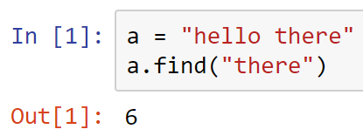
* 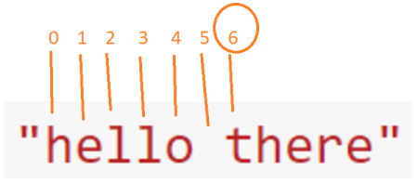
* In the example above, the word “there” is found in location 6
* If a word or letter is not found, find() function will return -1
* 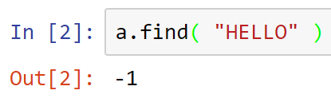
* Note that find() function is case sensitive
* Now, to the program …
* First, read the text file
* 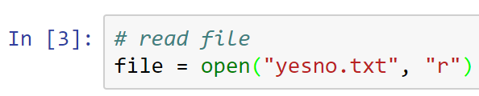
* Read one record at a time and store them in lines
* Then close the file
* 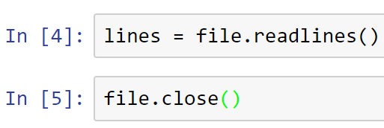
* Print lines to view what you have read
* 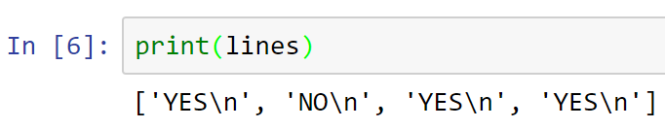
* Note the “new lines” (\n, or carriage returns) added at the end of each record
* Looking for patterns
* We need to setup counters
* 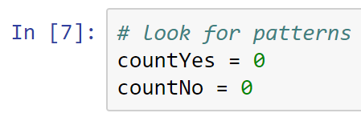
* Now, count the YES and NO. Be careful where you type the colons
* 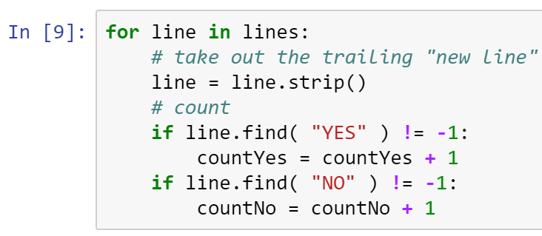
* Note: To convert all letters in a line to all caps, type: line = line.strip()**.upper()**
* To make sure that a “NOT” is not counted as “NO” and “YESYES” is not counted as “YES”, type: if line.find( “YES” ) != -1 **and len(line)==3:**
* if line.find( “NO” ) != -1 **and len(line)==2:**
* Print counters
* 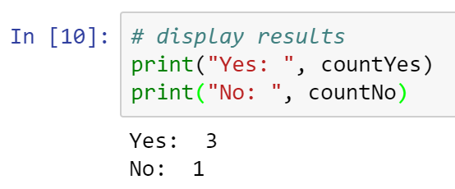
* Play around with your yesno.txt file, and see if your output is consistent with the changes you made to the file.
* All submissions should be separate from other exercises and quests. Please do not lump all your answers into one document and re-using that same workspace to gain multiple points. Thanks.
* Place your name at the bottom of your code, download your Python program in html format, and submit your work in Canvas.